Document Number | QRP2
Document Title | Control of Quality Records
Department Ownership | Quality & Risk Department
Document Type | Procedure
Department Owner | Derrick Chan
Document Author | Derrick Chan
Last Edited By | Derrick Chan | Lasted Edited On | 02/12/2014

Purpose

To describe the method of handling quality records for security purposes, and to allow for easy retrieval when required for analysis. To indicate where quality records will be stored, minimum retention period, and who the custodians are.

Scope

This procedure provides control and supports the retaining of evidence that quality system elements falling within the requirements of ISO 9001:2008 have been implemented. If the results have not proved satisfactory, quality records should indicate what has been done to correct the situation.

Reference Documents

QMS Database
ISO 9001:2008
Quality & Risk Manual

Definitions

Custodians – Personnel designated the guardians of the quality records.
Quality Records – All records generated through the adherence to the documented procedures.
They are an integral part of the quality system as they demonstrate achievement of the desired quality and the effective operation of the quality system.

Flowcharts (Other Images)

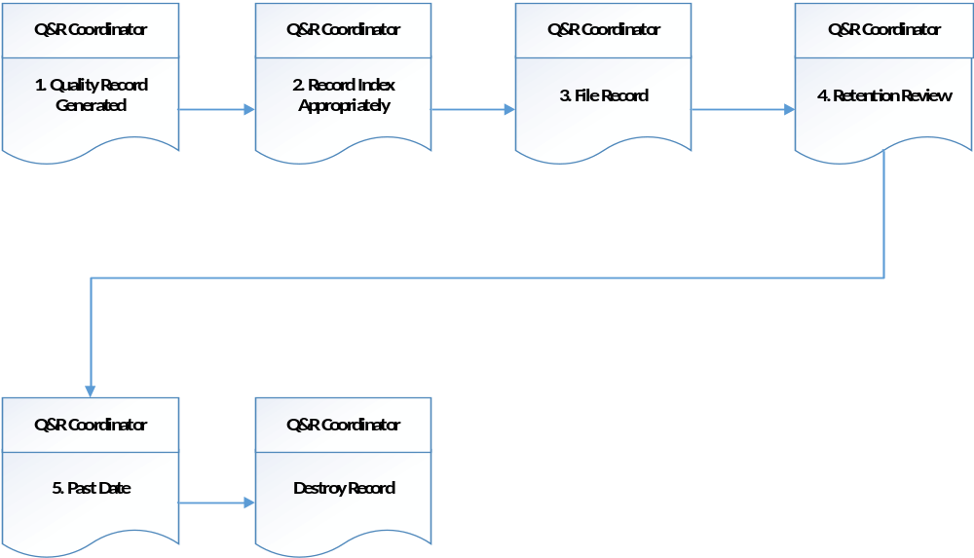

Procedure

- Quality Record Generated

Legible records shall be generated and maintained to support and substantiate all quality related activities. These quality related activities are as follows:

- System and compliance audits;

- Verifications performed in accordance with corrective and preventive action;

- Reliability of procurement sources;

- Control of non-conforming product;

- Tests performed approvals and audits by agencies;

- Calibration records;

- Customer complaints;

- Inspection of test records;

- Job records.

Quality records will be accessible as and where needed. They can be stored in any suitable form, for example, hard copy or electronic media. Any copies of quality records should contain all the relevant information in the original quality records. Records shall be stored in a suitable environment to minimise deterioration or damage and to prevent loss.

Redimed recognises that all completed pro-form as are considered as quality records. However, all pro-form as referenced in procedures and work procedures are indicative of forms used in the work situation and department managers and department supervisors are responsible for maintaining their currency.

- Record Index Appropriately

Quality record must be indexed with appropriate references such as Job No, File No. and Date etc.

Reason: To ensure easy retrieval

- File Record

Custodian to ensure record is legible and identifiable to the process for which custodian is responsible. Record is filed and indexed for easy retrieval.

From time to time staff members may require access to these quality records. For purposes such as management reviews or for analysis purposes, copies can be provided.

Access to records is restricted as necessary so that confidentiality is maintained.

Reason: To store for later retrieval

- Retention Review

Conduct a periodic review of the retention dates of records: -

Type of Document | Retention Period (Minimum) | Custodian | Where Stored
Approved Review Supplier | 5 years | Facility Manager | Redimed Files
Management Review Minutes | 5 years | QA Coordinator | Quality & Risk Office
Inspection & Test Records | 7 years | Manager/Supervisor | RediMed Files
Calibration Records | 7 years | Manager/Supervisor | RediMed Files
Non-Conformance Reports | 2 years | QA Coordinator | Quality & Risk Files
Corrective Action Reports (PIR’s) | 2 years | QA Coordinator | Quality & Risk Office

Quality Audit Reports | 2 years | QA Coordinator | Quality & Risk Office
Job Records | 5 years | Department Managers | Department Managers Office
Training Records | 5 years | Human Resources | Human Resources Office
Customer Complaints | 5 years | QA Coordinator | Quality Management System
Design Records (Review & Validations etc.) | 5 years | Department Managers/Supervisors | Department Managers/Supervisors Office
Time Recording Sheets | 2 years | Department Managers/Supervisors | Department Managers/Supervisors Office
Reason: To purge files of old records

- Past Date

Has minimum date of retention been reached? If not wait till next review, otherwise go to stage 6.

- Destroy Record

Destroy records past their retention date.

Reason: To maintain currency of records

Appendices

